CIE
COPYRIGHT INFORMATION EXTRACTION FORM
TITLE: Cloud-Based Industrial Digital Twin Platform for IoT-Integrated 3D Asset Monitoring and Predictive Analytics
SCHOOL: Chitkara University, Rajpura, Punjab
DETAIL OF THE STUDENT/MENTOR WHO UPLOADED THE COPYRIGHT ON GOVT PORTAL NEED TO SHARE LOGIN AND PASSWORD WITH MENTORS
Name: Sparsh Mittal
Roll No/ Employee Code: 2210990865

All MEMBERS DETAILS INCLUDING SUPERVISOR
NAME | EMP CODE/ROLL | ADDRESS WITH EMAIL AND MOBILE NO.
Sparsh Mittal | 2210990865 | Sparsh865.be22@chitkara.edu.in 8264096826
Payal | 2210992037 | Payal2037.be22@chitkara.edu.in 8617508868
Arshpreet Singh | 2210991370 | Arshpreet1370.be22@chitkara.edu.in 9872780785
Prof. Dr. S. B. Goyal | CET1003885 | Dean, Department of Computer Science & Engineering, Chitkara University, Punjab, India, shyam.goyal@chitkara.edu.in; 9220902139

ABSTRACT
  - Problem Background
Modern industrial infrastructure and environment rely upon the continuous monitoring of machines to make sure reliability, efficiency, and reduced downtime. However, traditional systems of monitoring are fragmented, where CAD-based designing models and IoT-based sensor data are processed individually, limiting the process of real-time visualization and analysis. Though the current platforms, such as Siemens Digital Twin and Azure Digital Twins, offer monitoring capabilities, yet real-time synchronisation between CAD models with IoT data streams via sensors, which is an area that can be exploited in representing the machines' real time behaviour with sufficient accuracy.
.
  - Objective of the Project
The objective of this project is to develop and provide an Industrial Digital Twin Platform based on the cloud, which enables synchronization in real-time amongst the CAD 3D models and IoT-based sensor data. This system's goals are to achieve low latency in synchronization (nearly 1–2 seconds), high accuracy in mapping (nearly 90–95%), and analytics that are improved by synchronization in real time engine and a layer of analytics.

  - Proposed Solution / System Overview
The proposed paper presents a system that is a digital twin platform based upon cloud that fuses optimized 3D CAD models with real-time IoT sensors to produce a synchronized digital twin of a physical industrial machine that is always in sync. This system architecture follows a structured data flow having: Input as CAD 3D file models and IoT based sensor data → Processing consists of data ingestion, mapping, it's synchronization, and analytics → Output as real time 3D visualization and its insights. A synchronization engine that is real-time maps the IoT based sensory data to the specific components of the 3D models, promising representation of machine behaviour which is accurate than any existing platforms. The major components comprise CAD 3D file processing, management of assets, IoT based data integration, a synchronisation engine that is real time, and dashboard visualisation, which together enable real-time monitoring and analytics.
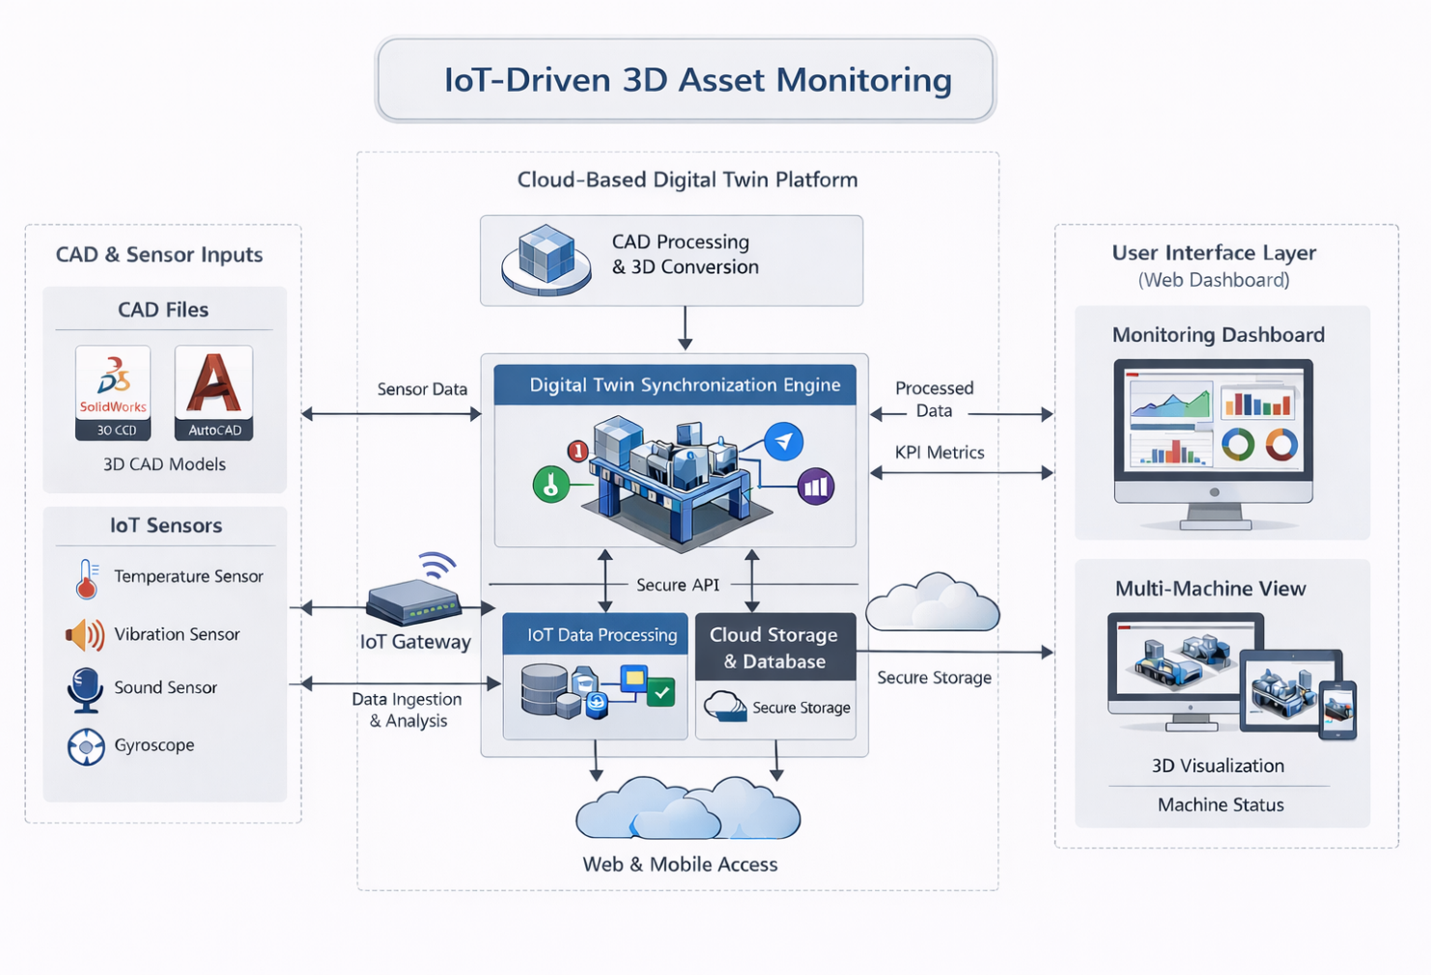
  - Key Features or Functionality
The platform provides real-time 3D visualization connected with real-time IoT sensor data with real-time low latency synchronization, sensor-to-component mapping, interactive dashboard and past data analysis. Its real-time and fine-grained component level synchronization, and real-time analytics provides superiority over traditional digital twin system. The platform also enables alert management, performance monitoring and anomaly detection mechanism to enhance operational visibility for more efficient and real-time decision making.
  - Technology / Method Used
The web uses SolidWorks and AutoCAD to develop the CAD models, and Blender for light-weight 3D optimization that web render quickly. For backend server side processing, using API and backend framework, and we rely on AWS as scalable cloud system. The whole architecture consists of layers, which include frontend(visualization), backend(processing) and cloud(storage & scalability).

  - Expected Outcome & Benefits
The system should attain synchronization latency of 1-2 seconds and mapping accuracy of 90-95%, by using a system that optimizes data processing and batching methods. The speed of anomaly detection should increase by 20-30%, and the system's maintenance effectiveness should enhance by 15-20%. Such figures are estimated by assessing the system design, sampling rates and processing logic. To perform verification, it would need to tested with live streams of sensor data and also look at the response time and effectiveness of detection when compared to an existing monitoring system.

  - Original Contribution Statement
The project proposes a synchronization engine which is real time, along with an IoT based sensor-to-component mapping model, promising integration of IoT data with precision alongside 3D models for enhanced digital twin accuracy and analytics that is real time.

